



**Disclaimer: The content is curated from online/offline resources and used for educational purpose only**

**LAB MANUAL**

**Unit III – Machine Learning**

**Unit III – Machine Learning**

**Lab 1. Predicting Solar Power Output Using Linear Regression with MS Excel**

**Objective**

To implement solar power output prediction using Linear Regression, a general approach to how you can tackle the solar power output prediction problem using linear regression, along with a sample implementation using Python and common libraries like Pandas, Scikit-learn, and Matplotlib. The model will be trained on historical data and will predict the solar power output for given values of the input features. The performance of the model will be evaluated using standard metrics such as Mean Squared Error (MSE) and R-squared (R²).

**Problem**

The global shift towards sustainable energy has led to an increasing reliance on renewable energy sources such as solar power. Accurate predictions of solar power output are crucial for effective grid management, energy storage, and optimizing the use of solar energy. we aim to predict the solar power output based on certain environmental factors, which include temperature, humidity, solar_irradiance and wind_speed. The goal is to develop a predictive model using Linear Regression, a simple yet powerful algorithm, to estimate the solar power output from these features.

**Solution**

To predict solar power output using linear regression and save the model, we'll go through the following steps:

1. Insert a Scatter Plot
   * Highlight the data range (A1).
   * Go to the Insert tab.
   * In the Charts group, click on Scatter and select Scatter with Straight Lines and Markers.
2. Add a Trendline (Linear Regression)
   * Right-click on any data point in the scatter plot.
   * Click on Add Trendline.
   * In the Format Trendline pane:
     1. Choose Linear.
     2. Check the box for Display Equation on chart (to display the regression equation).
     3. Check the box for Display R-squared value on chart (to display the goodness of fit).
3. Predict Future Solar Power Output

**Procedures**

**1. Insert a Scatter Plot**

1. Highlight the data range (A1).

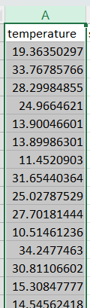

1. Go to the Insert tab.

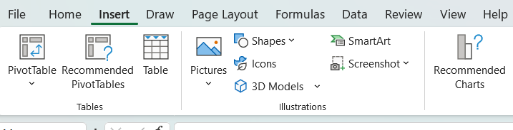

1. In the Charts group, click on Scatter and select Scatter with Straight Lines and Markers.

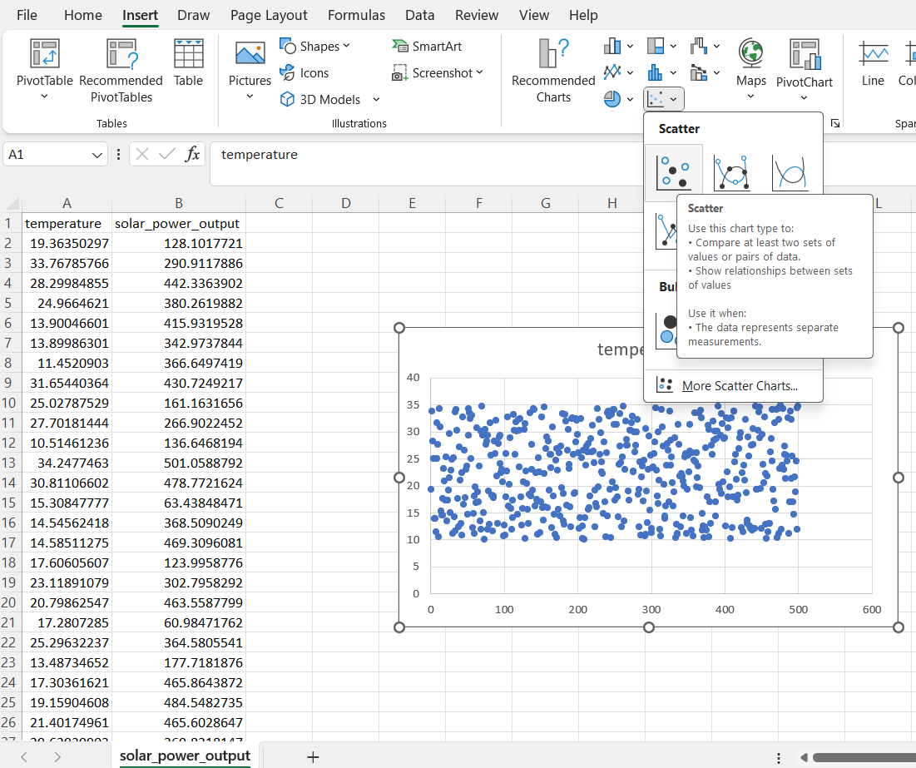

* + This will create a scatter plot of the data points.

**Add a Trendline (Linear Regression)**

1. Right-click on any data point in the scatter plot.
2. Click on Add Trendline.

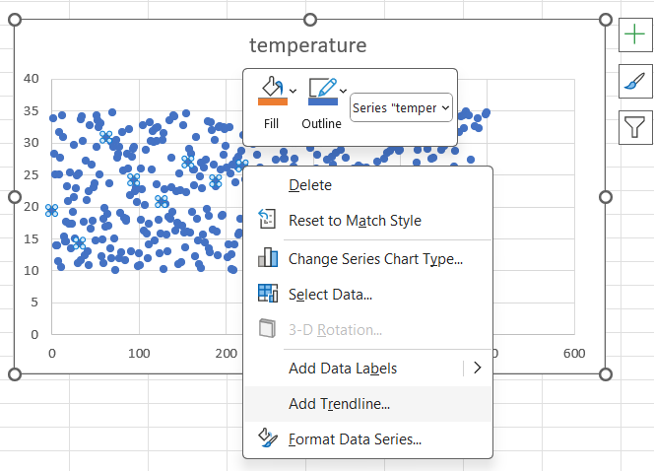

1. In the Format Trendline pane:

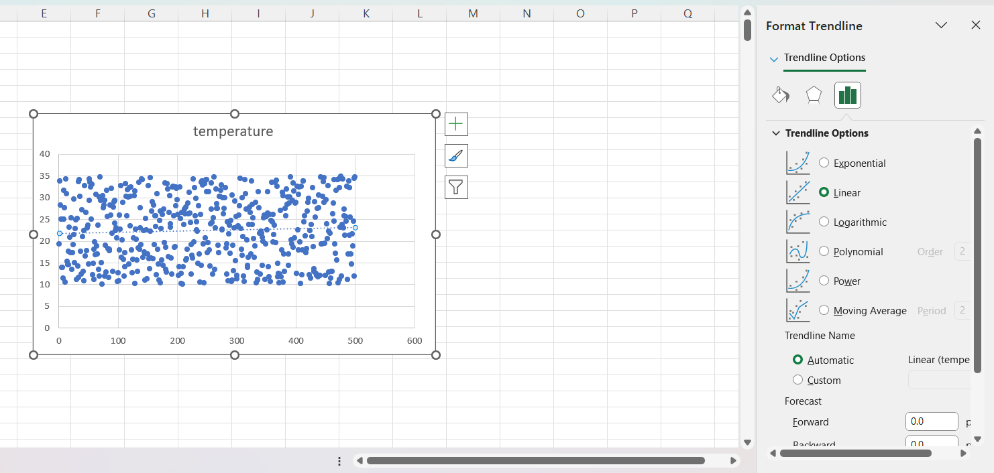

* + Choose Linear.

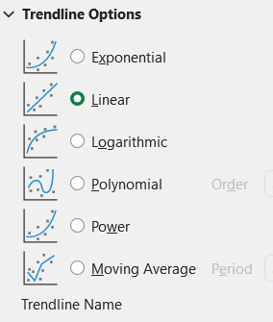

* + Check the box for Display Equation on chart (to display the regression equation).
  + Check the box for Display R-squared value on chart (to display the goodness of fit).

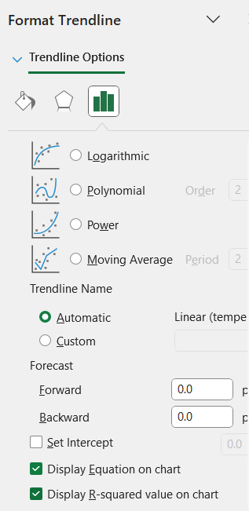

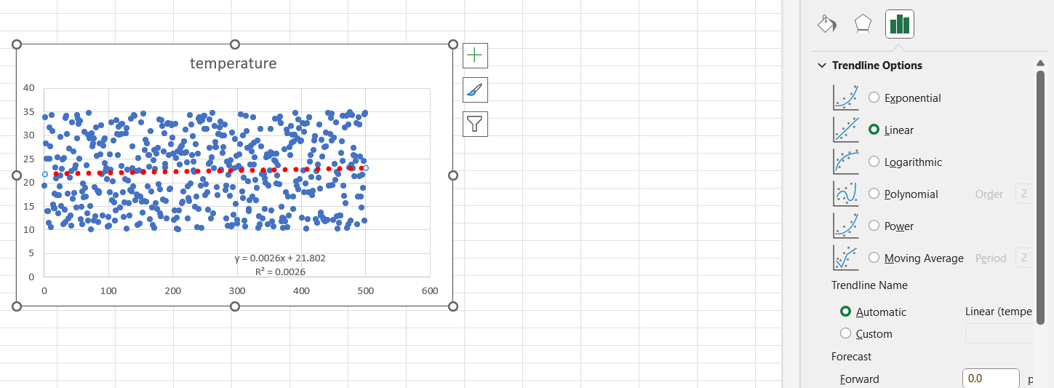

This will add a straight line to the scatter plot, representing the linear regression model, and display the equation and R-squared value.

**Predict Future Solar Power Output**

**the following regression output from Excel**

y = 0.0026x + 21.802

R² = 0.0026